Great! You already have a solid Python program for a school management system. To make this accessible on the web, you'll need to:
- Create a web interface (front-end): This is the part users interact with (forms, buttons, displays).
- Develop a backend server (backend): This will run your Python code and handle requests from the web interface.
- Integrate your existing code with a web framework.
Since you're a beginner, I'll guide you step-by-step:

Step 1: Choose a Web Framework
For Python, popular beginner-friendly frameworks include:
- Flask (lightweight, simple to get started)
- Django (more features, but more complex)
I'll recommend Flask because it's easier and lighter.

Step 2: Set Up Your Environment
- Install Python (if you haven't already).
- Create a new directory for your project.
- Create a virtual environment:
python -m venv venv
source venv/bin/activate # On Windows: venv\Scripts\activate
- Install Flask:
pip install flask

Step 3: Create a Flask App
Create a file named app.py in your project folder. Here's a basic example:
from flask import Flask, render_template, request, redirect, url_for

app = Flask(__name__)

# Your School class code here (copy your class code into this file or import it if in another file)

# Instantiate your school object
school = School()

@app.route('/')
def home():
return render_template('index.html')

# Add routes for each operation, e.g., add student, view students, etc.
# For brevity, I'll show just one example: view students

@app.route('/students')
def view_students():
students = school.students
return render_template('students.html', students=students)

# Add more routes similar to the above for other actions

if __name__ == '__main__':
app.run(debug=True)

Step 4: Create HTML Templates
Create a folder called templates, and inside it, create HTML files like index.html, students.html, etc.
Example index.html:
<!doctype html>
<html>
<head><title>School Management System</title></head>
<body>
<h1>Welcome to School Management System</h1>
<ul>
<li><a href="{{ url_for('view_students') }}">View Students</a></li>
<!-- Add more links for other actions -->
</ul>
</body>
</html>

Step 5: Run Your App
Back in your terminal, run:
python app.py
Open your browser and go to http://127.0.0.1:5000/

Next Steps:
- Create forms (HTML forms) to add students, teachers, courses, etc.
- Handle form data in Flask to call your existing class methods.
- Expand your Flask routes to handle all features.

Simple Example to Add a Student via Web:
In app.py, add:
@app.route('/add_student', methods=['GET', 'POST'])
def add_student():
if request.method == 'POST':
student_id = request.form['student_id']
name = request.form['name']
school.add_student(student_id, name)
return redirect(url_for('view_students'))
return render_template('add_student.html')
And create add_student.html:
<!doctype html>
<html>
<head><title>Add Student</title></head>
<body>
<h2>Add Student</h2>
<form method="post">
Student ID: <input type="text" name="student_id" required><br>
Name: <input type="text" name="name" required><br>
<input type="submit" value="Add Student">
</form>
</body>
</html>

Final notes:
- Keep your code organized—separate your class definitions and Flask app.
- When you're ready to go live, you can deploy your app on services like Heroku, PythonAnywhere, or VPS.

Would you like me to help you:
- Write the full code for the Flask app?
- Guide you step-by-step in developing a simple web interface?
- Or explain deployment options?
Let me know!

To make this front-end work with your existing Python code, we’ll need to connect it using a Flask backend. Let me know if you want me to help you create that Flask integration too.

✅ Your Flask backend is ready!
How to Run the Backend:
- Make sure you have Flask and Flask-CORS installed:
- pip install flask flask-cors
- Save the backend code in a file, for example: backend.py
- Run it:
- python backend.py
It will start a local server at: http://127.0.0.1:5000
How to Connect Front-End and Backend:
- Open your HTML frontend in a browser.
- It will automatically send data to the backend via the endpoints:
  - /add_student
  - /add_teacher
  - /add_course
  - /enroll_student
If you're hosting them separately (e.g., HTML in browser, backend on localhost), make sure both are running on the same machine and that the browser allows CORS.
Let me know if you want:
- Persistent data storage using SQLite
- Deployment instructions (e.g., to PythonAnywhere, Render, or Heroku)
- A dashboard to view lists of students, teachers, and courses
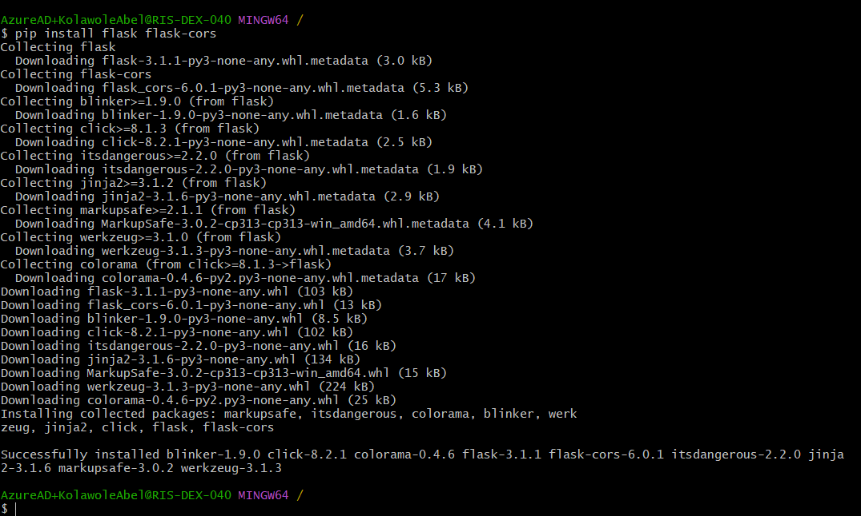
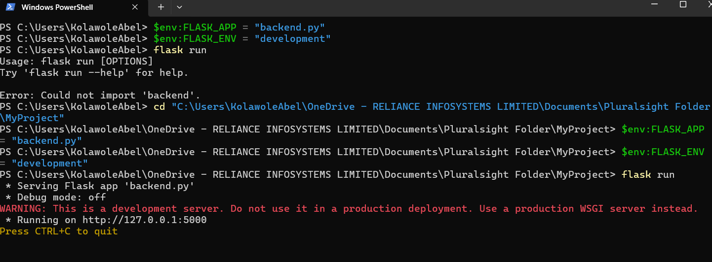
Perfect, Abel — it’s working now! ✅🎉
You're seeing:
* Serving Flask app 'backend.py'
* Running on http://127.0.0.1:5000
That means your Flask backend is running successfully!

✅ Next Step: Connect the Frontend
Now that the backend is live, do this:
1. Open the HTML file you created earlier (the one with the web forms) in your browser.
You can simply double-click it to open in Chrome or Edge.
2. Try adding a student or teacher using the form.
When you click "Add Student" or "Add Teacher", it should send data to:
http://127.0.0.1:5000/add_student
http://127.0.0.1:5000/add_teacher
If all goes well, you’ll see a success message in the browser under the form like:
Student John Doe added successfully.

🛠 If It Doesn’t Work:
If you don’t see anything happening:
- Open Developer Tools in your browser (press F12)
- Go to the Console or Network tab
- Try submitting the form again and check for errors

Let me know what happens when you try the HTML form — I’m here to help you finish the full connection!

